**PRCO204 Project management review**

**Use of the Agile philosophy for this project**

* Roadmap / Story map

We used a story map as our roadmap, this worked well with the agile philosophy as we were able to set out objectives in terms of functionality for each stage of the project. This helped us set clear goals for what needed to be achieved at each stage of the project. It was then just a matter of dividing up the work for the current sprint and then reviewing progress.

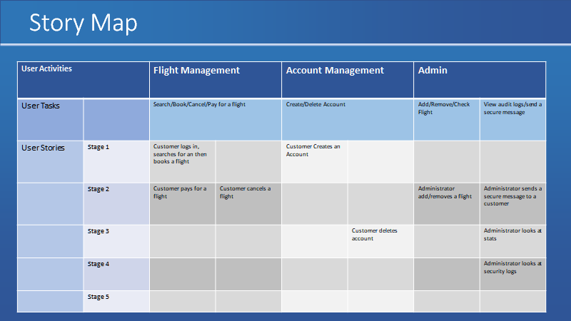

* Backlog / Who implemented what

To be completed by Jack

* Gradual implementation of functionality

In this project rather than follow the waterfall approach of development, we gradually added functionality at each stage of the project. This meant even the design was agile and would change as new functionality was added. This approach worked well for a team as it was easy to focus on a small subjection of the project and have a fixed timescale of two weeks to achieve this.

**Meetings / Communication**

* Sprint planning

To be completed by Joe

* Weekly meetings and communication

To be completed by Joe

* HCI assessment feedback and response

To be completed by Joe

**Security**

* Security risk assessment

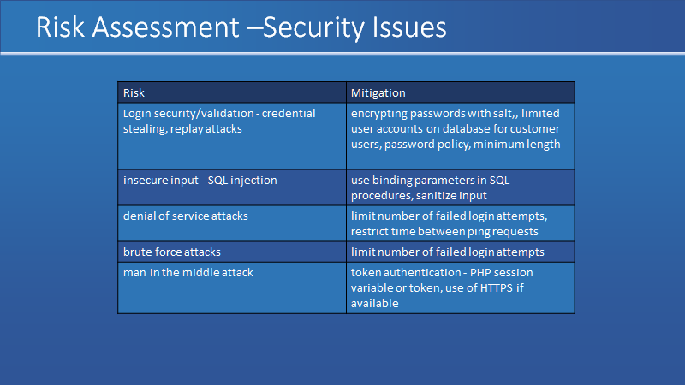

* Mitigation

At the start of the project we included a security risk assessment which identified security vulnerabilities and how they could be mitigated. Hashed passwords we used in the database as a security measure, we did not have access to SSL/HTTPS for this project, but if that was available the security could have been increased. Calls to the database were done using binding parameters which protected against SQL injection and an audit log was added which records all reads and writes to the database. A Caesar cipher was implemented to create secure messages. Not all vulnerabilities were mitigated in the risk assessment as we had limited resources.

**Evaluation / Lessons learned**

* What went well

We managed to finish all task in the required amount of time. We completed every task on the story map and user were able to use all the function implemented in the website.by implementing many sprints we were able to work precisely on each task. Furthermore, we always had a meeting every Friday on zoom or in class, where we are trying to discuss and solve the difficulty everyone was facing on their task. Overall everything works well and working as a group help us develop our communication skill and project management skill.

* What could have been improved

As a measure of improvement, we could have implemented more task in the website, add some extra functionality that might be suitable for a random user. We could have get more user responding to the HCI assessment and prepare efficiently before any weekly presentation.